Insurance company Data Analysis Report
Data Understanding /Description:
Age:
- Minimum_age:18, maximum_age:60
- The purchasing amount of insurance is high in age group 40.
Age distribution :
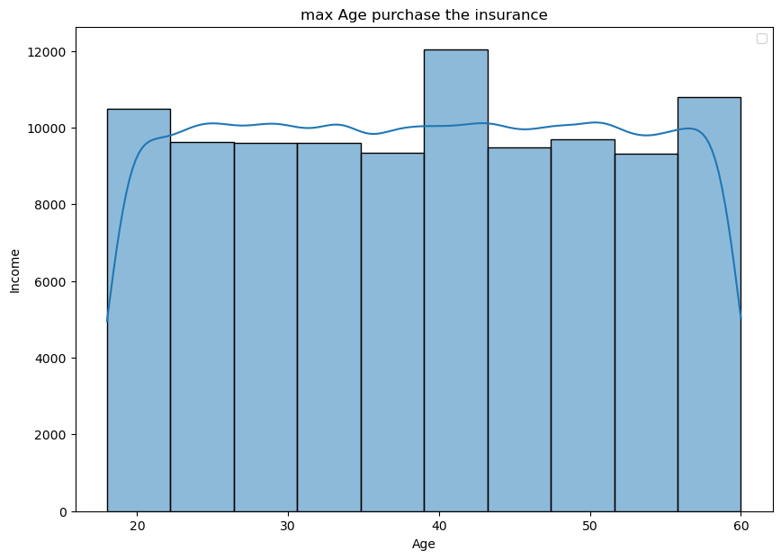
Gender:
- In gender males are 60076 & females are 39875
- Missing values are filled by mode(male)
- Most of the males are purchasing the insurance policy
Gender distribution in Insurance policy:
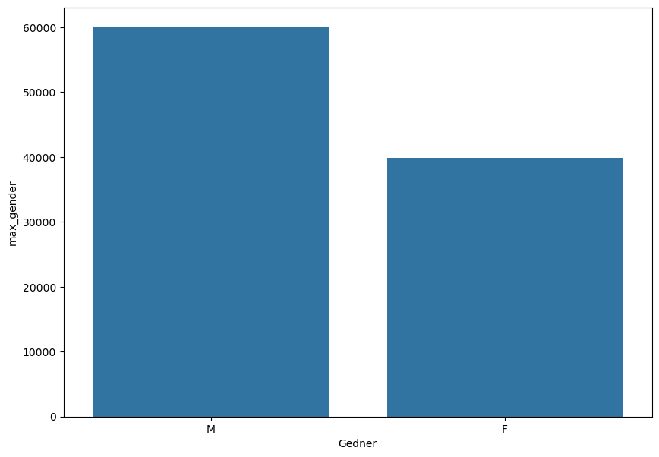

Marital status:
- Married :53966
- Divorced:23151
- Single:22834
- Married people’s are purchasing more number of insurance
Marital status distribution according to policy:
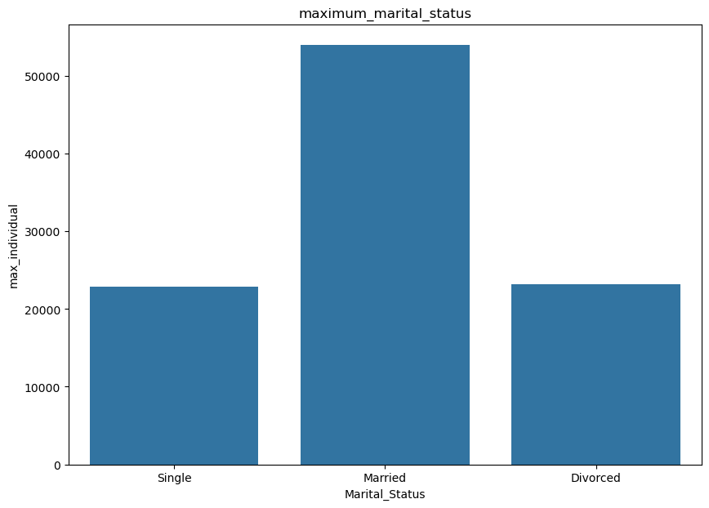
Family members:
- Most family have 2 to 4 members
- Most people purchasing insurance which having 2 to 6 members
- Mostly new coverage packages are purchasing which have 2 to 4 members in family
Distribution of family members according to new coverage:
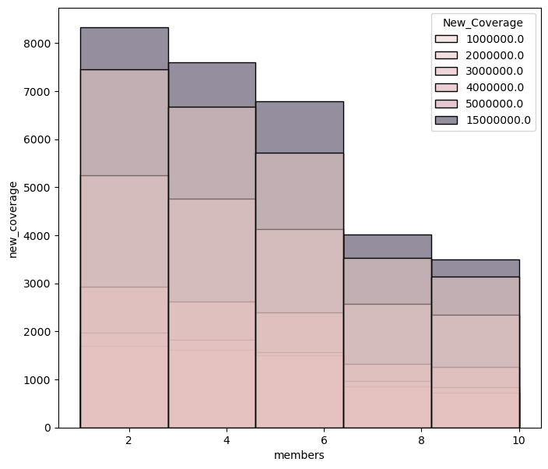
Occupation:
- SPT :52004
- SE:39426
- SET:852
- The SPT occupation has more number of current coverage (15000000)
- The SE occupation has (12500000) of current coverage

Current coverage according to occupation:
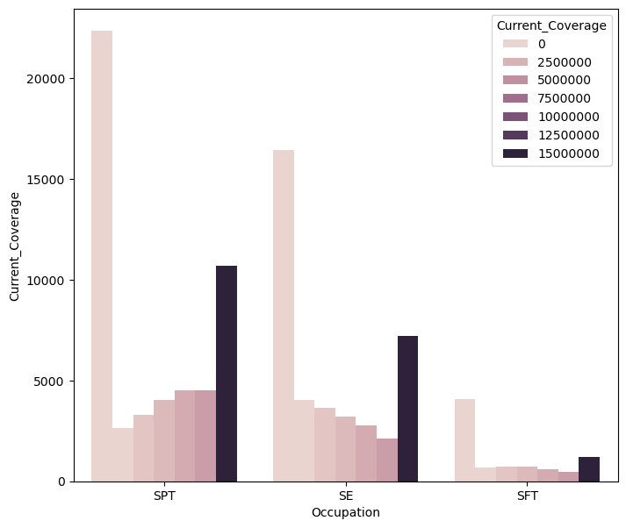
Current Product type:
- Most purchasing product is ANS
- Least purchasing product is END
- Trying to sale ANS and TLE the people having age 35 to 55

Current product type distribution:
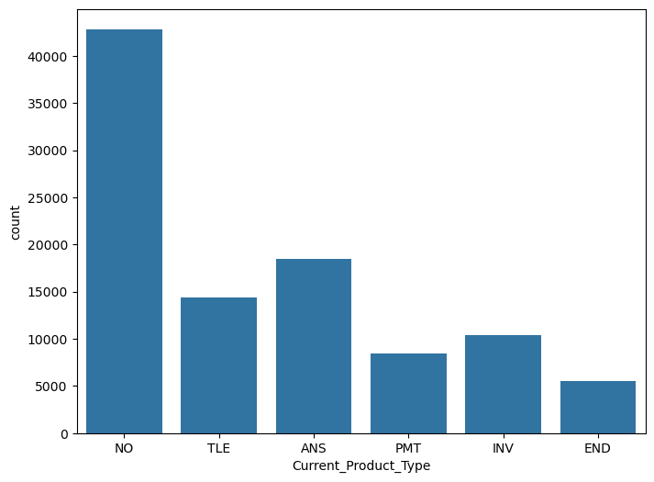

New product type:
- Most of the people like PMT
- Average new product liked by age numbers between 35 to 45
New product distribution: 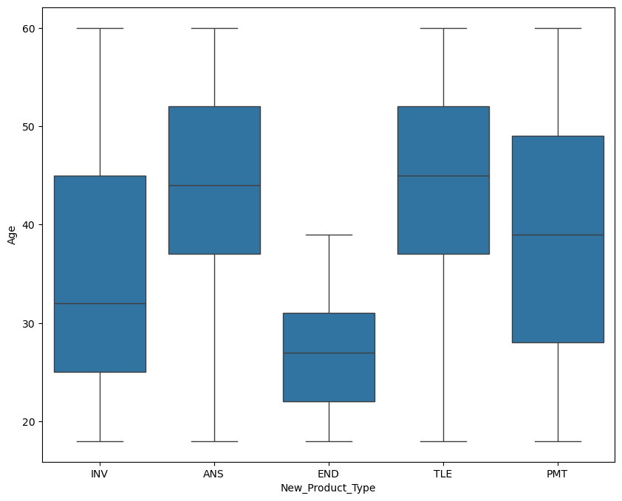

Rating:
- Target the people who gave a "Warm" rating but did not convert, and try to convert them.
- On average, 20,000 converted people gave a "Hot" rating.
- 15,000 converted people gave a "Warm" rating.
Rating according to product: 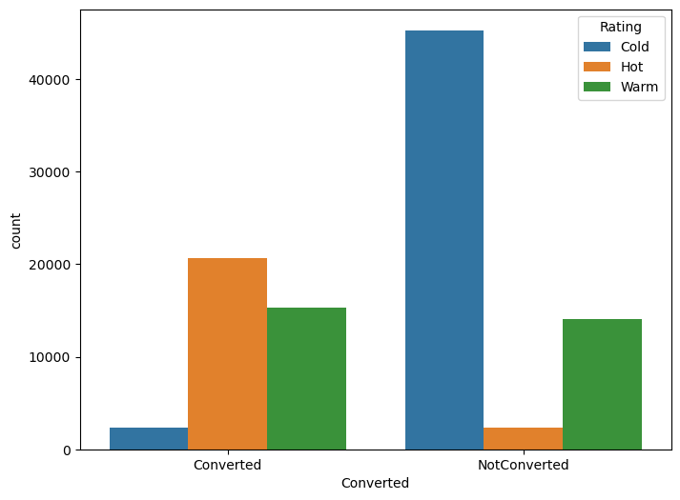

Summery of the data from insights:
The data shows that most people buying insurance are between 18 and 60 years old, and those around 40 years buy the most. There are more males (about 60,000) than females (about 40,000), and missing gender data was filled with “Male.” Married people are the main buyers of insurance. Most families have 2 to 4 members, and people with such family sizes buy more new coverage plans. Among jobs, people in the SPT group have the highest insurance coverage, followed by those in SE. The most popular current product is ANS, and the most liked new product is PMT, especially among people aged 35 to 45. Customers who gave a “Hot” rating are more likely to buy insurance, while those who gave a “Warm” rating but didn’t buy should be focused on next.

